Post-Quantum Cryptographic Signatures on
High-Throughput Blockchain Consensus
A Discrete-Event Simulation Parameterised to Solana’s Constraints
St Andrews Blockchain Society
Shahbaz Zulkernain, Kyla Biesty, Joshua Beukes, Alistair Mclair

March 2026

Code & Data: https://github.com/Shahbaz-z/UOSA_PQC

Contents
Contents 2
1. Abstract 4
2. The Threat Model — Why PQC is Inevitable 5
2.1 Shor’s Algorithm and ECC Vulnerability 5
2.2 Q-Day Timeline 5
2.3 “Harvest Now, Decrypt Later” — Blockchain’s Unique Exposure 5
2.4 NIST PQC Standardisation 6
2.5 Blockchain Industry Response (2025–2026) 6
2.6 Situating This Work 6
3. Methodology — The Simulator Architecture 7
3.1 Discrete Event Simulation Engine 7
3.2 Network Model 7
3.3 Block Construction Model 7
3.4 Signature and Key Size Catalog 7
3.5 Propagation Model 7
3.6 Verification Model 8
3.7 Stale Block Detection 8
3.8 Monte Carlo Sweep Design 8
3.9 Limitations, Assumptions, and Known Simplifications 9
4. Data & Results — The Bloat Matrix 11
4.1 Block Size Expansion 11
4.2 Propagation Delay Growth 12
4.3 Stale Rate Escalation 12
4.4 The Critical Threshold 13
4.5 Verification Time: The Non-Bottleneck 14
4.6 Root Cause Analysis: Bandwidth vs Compute 14
4.7 Baseline Calibration 15
4.8 Sensitivity Analysis: Algorithm Mix 15
5. Discussion 18
5.1 Vote Transaction Implications 18
5.2 Fee Market Dynamics and Dual Failure Modes 18
5.3 Algorithm Mix as Policy Variable 18
6. The Decentralisation Crisis 19
6.1 Validator Economics Under PQC Stress 19
6.2 The Stale Block Tax 19
6.3 Geographic Inequality 19
6.4 The Centralisation Feedback Loop 19
6.5 Cloud Provider Concentration Risk 19
7. Mitigations & Future Work 21
7.1 Hybrid Signatures 21
7.2 Falcon as a Middle Ground 21
7.3 Signature Aggregation 21
7.4 Zero-Knowledge Proof Compression 21
7.5 Protocol-Level Mitigations 21
7.6 Open Questions for Future Work 22
8. Conclusion 23
References 24

1. Abstract
This report presents a discrete-event simulation engine modelling the impact of post-quantum cryptographic (PQC) digital signatures on blockchain network performance. The simulator targets a generic high-throughput, short-slot blockchain parameterised to Solana’s published constraints - 400 ms slot intervals, 6 MB block size limits, and Ed25519 as the baseline signature scheme. PQC adoption is swept from 0% to 100% for transactions. A Monte Carlo sweep of 210 independent simulations (21 adoption levels × 10 seeds) was executed across 75 nodes (50 stake-weighted validators and 25 full nodes) distributed across multiple geographic regions, using the default PQC signature mix defined in Section 3.3.
The principal finding is that bandwidth consumption - driven by signature and public-key expansion - is the dominant bottleneck, not computational speed. Block sizes grow by an order of magnitude under full PQC adoption, pushing propagation delays to the edge of the slot window and triggering cascading consensus failures well before full adoption is reached. Sensitivity analysis reveals that this critical threshold is strongly dependent on algorithm choice, but no tested mix avoids severe degradation at production-level transaction rates.

A critical failure threshold is identified at approximately 37% PQC adoption, beyond which stale block rates exceed 30% and marginal validator operations become economically unviable. This threshold, however, carries important caveats in both directions: the fanout-8 gossip model underestimates Turbine's tree-structured propagation efficiency, biasing the threshold downward, while the absence of NIC contention modelling biases it upward. Additionally, P90 propagation metric excludes nodes that failed to receive the block within the simulation window, providing another upward bias. The net direction of error is uncertain, and the figure should be treated as an order-of-magnitude estimate rather than a precise prediction.

The deeper risk is not chain failure but centralisation. PQC-induced block bloat disproportionately disadvantages validators with constrained bandwidth and geographic latency, concentrating the network among well-resourced operators. Naïve signature substitution without protocol-level mitigation - signature aggregation, proof compression, or adaptive block sizing - would systematically erode the decentralisation properties that underpin their security model. With expert consensus placing Q-Day in the early-to-mid 2030s, at most a single decade remains for protocol-level preparation.

2. The Threat Model - Why PQC is Inevitable

2.1 Shor’s Algorithm and ECC Vulnerability
The security of all major blockchain signature schemes - ECDSA (Bitcoin, Ethereum), EdDSA/Ed25519 (Solana, Cardano) - rests on the computational hardness of the Elliptic Curve Discrete Logarithm Problem (ECDLP). The best classical attack requires approximately 2¹²⁸ group operations, placing brute-force recovery of private keys beyond classical reach [1].
Peter Shor’s 1994 quantum algorithm reduces this problem to polynomial time. Rötteler et al. [4] established that breaking a 256-bit ECC curve requires approximately 2,330 logical qubits - substantially fewer than the ~6,146 needed for RSA-3072 at equivalent classical security, making ECC more vulnerable to quantum attack than RSA.
Subsequent algorithmic improvements have progressively reduced these requirements. Litinski [5] demonstrated that secp256k1 can be broken with only 50 million Toffoli gates, a 300-fold reduction depending on the operating regime. Separately, Babbush et al. [6] using a repetition cat-qubit architecture showed that the 256-bit ECDLP can be solved in 9 hours using 126,133 physical cat qubits - far fewer than earlier estimates. The 2025 ‘Brace for Impact’ challenge ladder by Dallaire-Demers et al. [5] projects that under optimistic assumptions, a CRQC could crack secp256k1 with a few × 10⁴ physical qubits in under a day.

2.2 Q-Day Timeline
A cryptographically relevant quantum computer (CRQC) is defined as a fault-tolerant quantum processor capable of running Shor’s algorithm at the scale necessary to break 256-bit ECC in tractable time. Current NISQ processors - including IBM’s 1,121-qubit Condor and Google’s 105-qubit Willow - lack sufficient error-corrected logical qubits. However, corporate roadmaps are converging on the early 2030s.
IBM targets 200 logical qubits by 2029 (Starling processor) and 2,000 logical qubits by 2033 (Blue Jay), the latter exceeding the estimated threshold for secp256k1 [8]. Google achieved a critical error-correction milestone with the Willow chip in late 2024 and targets thousands of logical qubits in the early 2030s [9]. IonQ’s 2025 roadmap [10] projects approximately 1,600 logical qubits by 2028 via photonically networked trapped-ion systems, though independent analysts express caution about this timeline.
The Global Risk Institute (GRI) 2024 survey [11] reports a 19-34% probability that a CRQC capable of breaking RSA-2048 in 24 hours will exist by 2034. Chaincode Labs [12] reports that one third of surveyed experts estimate a ≥50% likelihood of CRQC emergence between 2030 and 2035. Both NIST [13] and the NSA [14] implicitly treat the 2030-2035 window as the expected threat horizon, setting mandatory migration deadlines accordingly.

2.3 “Harvest Now, Decrypt Later” - Blockchain’s Unique Exposure
The ‘Harvest Now, Decrypt Later’ (HNDL) threat involves adversaries recording cryptographically protected data today and archiving it until a CRQC becomes available for retrospective decryption. A 2025 Federal Reserve working paper [15] concluded that blockchain data from 2009 onward is subject to the HNDL threat, since every on-chain transaction is permanently and publicly accessible.

2.4 NIST PQC Standardisation
On 13 August 2024, NIST published the first three post-quantum cryptographic standards [16]: FIPS 203 - ML-KEM (Module-Lattice-Based Key-Encapsulation Mechanism), derived from CRYSTALS-Kyber, for asymmetric encryption and key exchange. FIPS 204 [2] - ML-DSA (Module-Lattice-Based Digital Signature Algorithm), derived from CRYSTALS-Dilithium, for quantum-resistant digital signatures replacing ECDSA/EdDSA. Three parameter sets are defined: ML-DSA-44, ML-DSA-65, and ML-DSA-87 at NIST security levels 2, 3, and 5 respectively. FIPS 205 [3] - SLH-DSA (Stateless Hash-Based Digital Signature Algorithm), derived from SPHINCS+, relying solely on hash-function security as a conservative backup.
A fourth standard, FN-DSA (Falcon, FIPS 206), producing significantly smaller signatures than ML-DSA, is nearing finalisation [17]. NIST IR 8547 [13], published November 2024, establishes the official transition timeline: quantum-vulnerable algorithms designated ‘not recommended’ by 2030 and fully removed from NIST standards by 2035. The NSA’s updated cryptographic suite [14] similarly mandates full quantum resistance for national security systems by 2035.

2.5 Blockchain Industry Response (2025–2026)
Ethereum Foundation. In January 2026, the Ethereum Foundation formally elevated post-quantum security to a top strategic priority [18], creating a dedicated PQC engineering team, announcing $2 million in research prizes, and initiating live post-quantum development networks. On 26 February 2026, Vitalik Buterin confirmed that Ethereum will achieve quantum resistance via hash-based signatures within the Strawmap [19] - a four-year Layer 1 upgrade plan targeting approximately seven network forks every six months.
Bitcoin BIP 360. On 11 February 2026, BIP 360 (Pay-to-Merkle-Root, P2MR) was officially merged into the Bitcoin Improvement Proposals repository [20], marking the first formal incorporation of quantum-resistance capabilities into Bitcoin’s technical roadmap. BIP 360 removes the standard key-path spend from Taproot architecture, dramatically reducing what a quantum attacker can target.
Solana. In December 2025, the Solana Foundation partnered with Project Eleven to deploy a functioning post-quantum signature system on a Solana testnet [21], demonstrating that quantum-resistant transactions are practical with current technology. An optional quantum-resistant Winternitz vault was also released for mainnet users.

2.6 Situating This Work
Existing PQC-blockchain literature focuses primarily on static block-space analysis or single-algorithm substitution cost estimates - quantifying how many fewer transactions fit per block when a classical signature is replaced by a PQC equivalent. While these analyses correctly identify signature size as the dominant cost driver, they do not capture the dynamic, second-order effects that emerge in a live network: how block-size inflation interacts with propagation delay, how propagation delay drives stale-block rates, and how stale rates feed back into validator economics and centralisation pressure. This work extends the conversation by modelling these coupled dynamics in a discrete-event simulation across a continuous PQC adoption spectrum (0-100%), identifying a phase transition in consensus stability that static analysis cannot capture. The simulator is parameterised to Solana’s published constraints but represents a generic high throughput blockchain model. The principal contribution is the quantitative demonstration that bandwidth consumption - not computational verification overhead - is the binding constraint (demonstrated in Sections 4.5-4.6), and that a sharp onset of cascading consensus failure emerges at a specific adoption threshold.

3. Methodology - The Simulator Architecture

3.1 Discrete Event Simulation Engine
The simulator is built on a custom heapq-based priority-queue scheduler. The engine maintains five event types, processed in strict chronological order: SLOT_TICK → BLOCK_PROPOSED → BLOCK_PROPAGATED → BLOCK_RECEIVED → BLOCK_VALIDATED. Time advances discretely between events; no continuous-time dynamics are modelled. All randomness is seeded for full reproducibility via random.Random(seed), ensuring that any simulation can be exactly replicated given the same seed and parameters.
The simulator codebase ( approximately 12,000 lines of Python) was implemented in Python 3.11 using AI-assisted development tools (Claude, Gemini) to accelerate coding. All model architecture design, parameter selection, validation methodology and data analysis were performed by the author.

3.2 Network Model
The simulated network consists of 75 nodes: 50 validators and 25 full nodes. Validators participate in block proposal via stake-weighted selection; full nodes receive, verify, and relay blocks but do not propose. Each node is assigned a geographic region via a region_distribution() function modelling realistic multi-region deployment. Individual nodes are parameterised by upload bandwidth, download bandwidth, CPU core count, and geographic region, sampled from sample_validator_config() and sample_full_node_config() respectively. Network latency between any two nodes is computed as the sum of geographic round-trip time and transmission time (block size divided by the minimum of sender upload and receiver download bandwidth).

3.3 Block Construction Model
Blocks are filled by fee-rate priority from the mempool up to the block_size_limit. Each transactions size is base_tx_overhead + sig_size + pk_size, where sig_size and pk_size depend on whether the transaction uses a pqc or classical signature. The maximum number of transactions per block therefore varies with the pqc fraction.For the Solana-parameterised baseline, the block size limit is 6 MB, the slot interval is 400 ms, and the base transaction overhead is 250 bytes. Blocks are heterogeneous: a pqc_fraction parameter controls what fraction of transactions use PQC signatures. The PQC signature mix is ML-DSA-44 (30%), ML-DSA-65 (50%), and SLH-DSA-128f (20%), reflecting a plausible near-term adoption scenario in which ML-DSA-65 dominates PQC deployment, with a smaller ML-DSA-44 comp onent and a 20% SLH-DSA tail providing hash-based diversity.

3.4 Signature and Key Size Catalog
Table 1 presents the cryptographic parameter catalog used in the simulator. PQC verification times are deliberately conservative, incorporating a 3-4× margin above wolfSSL benchmark measurements [23] (e.g., 180 µs vs wolfSSL’s 54 µs for ML-DSA-44; 300 µs vs 87 µs for ML-DSA-65). The classical Ed25519 baseline uses a more modest 1.4× margin (60 µs vs wolfSSL’s 44 µs). This asymmetry strengthens the central conclusion: since PQC verification times are inflated more aggressively than classical times, any finding that PQC verification remains within budget is conservative.
Table 1: PQC Signature and Key Size Catalog. Sources: FIPS 204 [2] Table 2, FIPS 205 [3] Table 2, wolfSSL benchmarks [23]. PQC times include 3-4× conservative margin; Ed25519 uses 1.4×.
Algorithm | Signature (B) | Public Key (B) | Verify (µs)
Ed25519 | 64 | 32 | 60
ECDSA | 72 | 33 | 80
ML-DSA-44 | 2,420 | 1,312 | 180
ML-DSA-65 | 3,309 | 1,952 | 300
ML-DSA-87 | 4,627 | 2,592 | 500
SLH-DSA-128f | 17,088 | 32 | 5,940
SLH-DSA-128s | 7,856 | 32 | 2,160
Falcon-512 | 666 | 897 | 100

3.5 Propagation Model
Block propagation follows a gossip protocol with configurable fanout. The Solana chain configuration specifies a fanout of 200 (intended to model Turbine’s tree-structured data distribution), but a precedence bug in the engine’s initialisation caused the global default of 8 to always override the chain-specific value. This bug has since been corrected in the codebase, but all sweep data presented in this report was generated under the bugged configuration. Critically, a fanout of 8 does not replicate Turbine’s tree-routing architecture; it represents a simplified flat gossip model. All sweep results therefore use fanout-8 flat gossip - a conservative simplification that underestimates Solana’s real propagation speed but also avoids overstating the precision of the Solana model. Propagation delay for each hop is computed as a static formula:
delay = geographic_latency + (block_size_bytes × 8) / effective_bandwidth
where effective_bandwidth = min(sender_upload, receiver_download). This is a static per-hop calculation, not a queuing model: simultaneous gossip transmissions from the same node each receive the full bandwidth allocation independently. The engine does not model NIC contention - there is no queuing or resource-sharing for concurrent uploads. As a result, propagation delays are underestimated in high-fanout scenarios (8 simultaneous transmissions do not compete for the NIC). This absence of bandwidth contention is detailed as Limitation (i) in Section 3.9.
This model captures the key empirical insight from Decker and Wattenhofer [22] that propagation delay scales approximately linearly with block size at a rate of ~80 ms per additional kilobyte for blocks exceeding 20 KB.

3.6 Verification Model
Verification scheduling uses an analytical min-heap model: each node maintains a core_free_at array tracking when each CPU core becomes available and assigns each signature verification to the earliest-free core. This produces equivalent scheduling behaviour to a discrete-capacity resource model, without incurring process-based simulation overhead. The min-heap scheduler is the sole verification mechanism in the current codebase.
PQC verification times per signature follow Table 1, with the conservative margins described in Section 3.4. This design choice is deliberate: by using pessimistic PQC verification times, any conclusion that verification remains within budget is strengthened - real hardware will perform better than the simulation assumes.

3.7 Stale Block Detection
A block is classified as stale if the 90th-percentile propagation time (P90) exceeds 90% of the block time - 360 ms for the 400 ms slot. This threshold follows the industry standard that a block risks orphaning when nearly the full slot elapses before network-wide receipt. The stale rate is computed as:
stale_rate = count(p90 > 0.9 × block_time) / total_blocks

3.8 Monte Carlo Sweep Design
The parameter sweep covers 21 PQC fraction levels (0%, 5%, 10%, ..., 100%) with 10 random seeds per level, yielding 210 independent simulations. Each simulation runs for 10,000 ms (10 seconds of simulated time) at a Poisson transaction arrival rate of λ = 4,000 TPS, producing approximately 25 blocks per run (at the 400 ms slot interval). The output comprises 30 columns of per-run summary metrics including block size statistics, propagation delay percentiles, verification times, throughput, and stale rates. The short per-run duration is offset by the breadth of the sweep: 210 independent runs across the full PQC adoption spectrum provide sufficient statistical power to characterise means, standard deviations, and tail behaviour.
At λ = 4,000 TPS, the mempool is lightly saturated at low PQC fractions but becomes heavily capacity-limited above approximately 45–50% PQC adoption, where blocks hit the 6 MB block size cap. Mean throughput is 4,164 TPS at 0% PQC (all transactions fit within the block) but declines to 2,695 TPS at 100% PQC as block truncation forces transaction eviction. Above the cap, the block size is fixed at approximately 5,858 KB regardless of PQC fraction, and the mempool experiences sustained backpressure with fee-market effects absent from lower arrival rates.

3.9 Limitations, Assumptions, and Known Simplifications
The simulator incorporates several known simplifications and modelling assumptions that should be carefully considered when interpreting results. These are listed in detail below.
(i) No bandwidth contention (NIC sharing).
Propagation delays use a static formula rather than a queuing model. Simultaneous gossip transmissions from a single node each receive the full bandwidth independently - the NIC is not shared. This underestimates real-world propagation delays, making the simulator’s conclusions more conservative (actual network degradation would be strictly worse). In a production network, NIC contention under high-fanout gossip would create queuing delays that compound with block-size inflation, likely triggering the observed onset of cascading failure at a lower PQC adoption fraction than the ~37% identified here.
(ii) Gossip fanout override and Turbine fidelity.
A precedence bug caused the global fanout default of 8 to override the Solana chain’s configured fanout of 200. This bug has since been corrected, but all sweep data uses fanout-8 flat gossip - a significant departure from Solana’s tree-structured Turbine protocol. The fanout-8 model underestimates Solana’s propagation speed under normal conditions but also avoids overstating model fidelity. The causal mechanism - signature expansion driving block-size growth driving propagation delay - is independent of gossip topology; Turbine would change absolute delay values but would not eliminate the phase transition. The simulator should therefore be understood as modelling a generic high throughput blockchain parameterised to Solana’s slot time and block size constraints, rather than a true replica of the Solana mainnet propagation protocol.
(iii) P90 propagation coverage bias.
The P90 metric is computed over whichever nodes have received the block within the simulation window. If only 60% of nodes receive a block (e.g. at very high PQC fractions where propagation is severely delayed), the P90 is the 90th percentile of that 60%, not of the full 75-node network. This introduces a survivorship bias: at extreme PQC fractions, the reported P90 delay may flatter the actual network state, as it only accounts for nodes that successfully received the block within the simulation window. Nodes that never received the block are excluded from the percentile calculation entirely.
(iv) Scaled network size.
The sweep uses 75 nodes (50 validators + 25 full nodes) and 10-second runs, compared to Solana mainnet’s ~795 validators and thousands of RPC nodes. The propagation topology scales linearly with node count, and the per-hop delay model is independent of network size. The qualitative dynamics (block size → propagation delay → stale rate) are preserved, though absolute percentile values would shift with a larger network. A larger network increases the number of gossip hops required for full propagation, which would amplify the delay differential between small (Ed25519) and large (PQC) blocks.
(v) Transaction arrival rate and block capacity.
The production simulation uses λ = 4,000 TPS. At this arrival rate, blocks are capacity-limited above approximately 45-50% PQC adoption, where the 6 MB block size cap becomes binding. Below this threshold, blocks contain approximately 1,600 transactions at 0% PQC and grow in byte size as PQC fraction increases. Above the cap, blocks are truncated to ~5,858 KB regardless of PQC fraction, and excess transactions accumulate in the mempool. The results therefore capture congestion effects, fee-market pressure, and throughput degradation that emerge under production-level load. Effective TPS drops from 4,164 at 0% PQC to 2,695 at 100% PQC - a 35% throughput loss driven entirely by block-size truncation under PQC signature expansion.
(vi) Analytical approximations.
The simulator uses an analytical min-heap scheduler for CPU verification and a static formula for propagation delay. These are deterministic approximations: the min-heap produces equivalent scheduling to a discrete-capacity resource model, and the static propagation formula captures first-order bandwidth effects without modelling queuing dynamics. A full process-based simulation with explicit resource contention (NIC sharing, CPU pre-emption) would yield strictly worse performance metrics, making the current results a conservative lower bound on degradation.

(vii) Static fee model.
All transactions are assigned fees from a static distribution; there is no dynamic fee market that responds to congestion. In a real network, PQC-induced block-space scarcity would drive fee escalation, potentially pricing out lower-value transactions before the stale-rate crisis manifests.
(viii) Uniform PQC adoption.
The pqc fraction parameter applies uniformly to all generated transactions. In practice, PQC adoption would be heterogeneous: early adopters might use ML-DSA while legacy wallets remain on Ed25519, creating a mixed ecosystem. The simulator does not model strategic adoption behaviour, migration incentives, or protocol-level fee adjustments that might differentially affect PQC and classical transactions.
(ix) Single-chain scope.
Although the codebase contains chain configuration for Bitcoin and Ethereum models, only the Solana parameterisation has been validated against the sweep data. Cross-chain comparisons (on the streamlit application) are based on static block-space analysis.
(x) No vote transaction overhead.
On Solana mainnet, approximately 70-80% of block space is consumed by validator vote transactions, which also require signature verification. The simulator does not model vote transactions separately; all transactions are treated as user transactions. Including vote overhead would further compress the available block space for user transactions under PQC, amplifying the degradation observed in this sweep.

4. Data & Results - The Bloat Matrix

4.1 Block Size Expansion
Below approximately 45-50% PQC adoption, block size grows approximately linearly with PQC fraction, consistent with the additive nature of the per-transaction size increase (Figure 1). Above this threshold, blocks hit the 6 MB block size cap and are truncated to approximately 5,858 KB regardless of further PQC fraction increases. At 100% PQC adoption, the mean block size reaches 5,858 KB - effectively at the cap. The expansion ratio of 10.4× relative to the 563 KB baseline understates the true signature-size inflation because blocks above ~45% PQC are truncated by the cap. Without the cap, the block size at 100% PQC would be substantially larger. The critical constraint is therefore not just propagation time but absolute block capacity: above ~45-50% PQC adoption, not all mempool transactions can fit within a single block, forcing transaction eviction and throughput degradation.
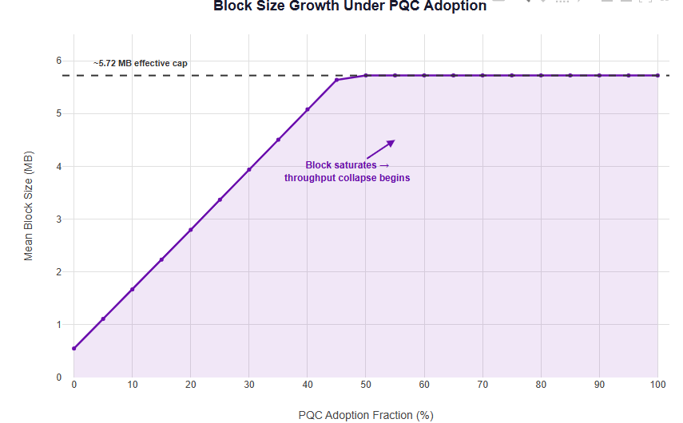
Figure 1: Mean block size growth with PQC adoption. The dashed line marks the 6 MB block size cap.

4.2 Propagation Delay Growth
Table 2 presents the propagation delay distribution at key PQC levels. The P90 metric is of particular significance because it determines whether the block can reach a sufficient fraction of the network within the 400 ms slot window.
Table 2: Propagation delay distribution as a function of PQC adoption fraction.
PQC % | P50 (ms) | P90 (ms) | P90 as % of Slot
0% | 109 | 186 | 46.4%
25% | 152 | 287 | 71.9%
50% | 192 | 404 | 101.0%
75% | 176 | 388 | 96.9%
100% | 169 | 381 | 95.3%
The P90 propagation delay grows from 186 ms at baseline to a peak of 404 ms at 50% PQC adoption - briefly exceeding the 400 ms slot (101.0% of slot). Above 50% PQC, P90 stabilises in the 380–395 ms range because block size is capped at ~5,858 KB: further increases in PQC fraction do not increase block size and therefore do not increase propagation time. At 100% PQC, the P90 is 381 ms (95.3% of slot), leaving only 19 ms of margin - a dangerously narrow buffer for any additional network jitter, validator processing overhead, or geographic latency variability. The median (P50) shows a similar pattern: it peaks near 192 ms at 50% PQC before declining to 169 ms at 100%, reflecting that block size is capped and fewer, larger transactions fill each block.
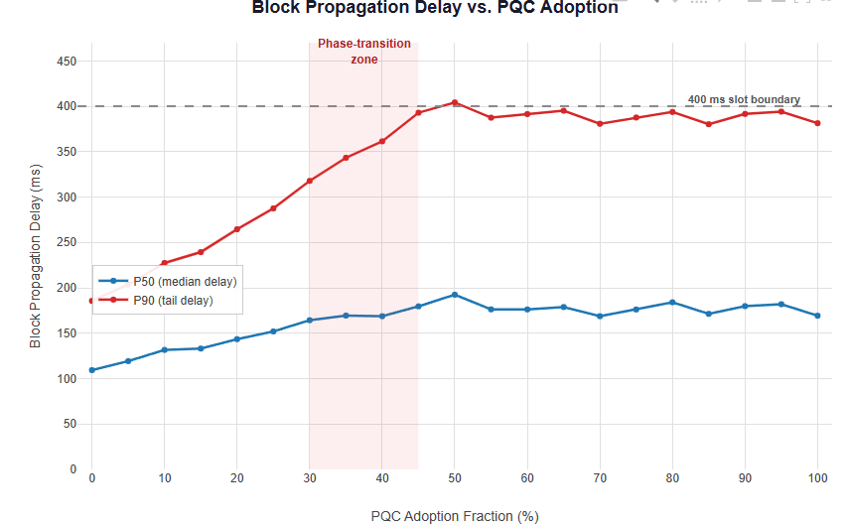
Figure 2: P50 and P90 propagation delay versus PQC adoption fraction. The shaded band indicates the 400 ms slot window.
P90 caveat. At extreme PQC fractions, the reported P90 delay may flatter the actual network state, as it only accounts for nodes that successfully received the block within the simulation window. Nodes that failed to receive the block before the next slot are excluded from the percentile calculation. The practical implication is that the true network-wide latency at high PQC adoption is likely worse than the reported P90 values suggest, and the effective propagation coverage (fraction of nodes receiving each block) declines as PQC adoption increases.

4.3 Stale Rate Escalation
The stale rate exhibits a sharp onset of degradation between 35% and 50% PQC adoption (Figure 3). Below 35% PQC, the network degrades manageably: the mean stale rate is 24.0% at 35% PQC. Between 35% and 40%, a dramatic jump occurs: the mean stale rate nearly doubles from 24.0% to 42.4%. By 50% PQC, the stale rate reaches 68.0% - meaning more than two thirds of all blocks are lost. Above 50%, the stale rate plateaus in the 63-70% range as block size is capped and propagation times stabilise near the slot boundary. The maximum observed stale rate reaches 96% in individual simulation runs at 50-100% PQC, indicating that under unfavourable random network conditions, nearly all blocks would be lost.
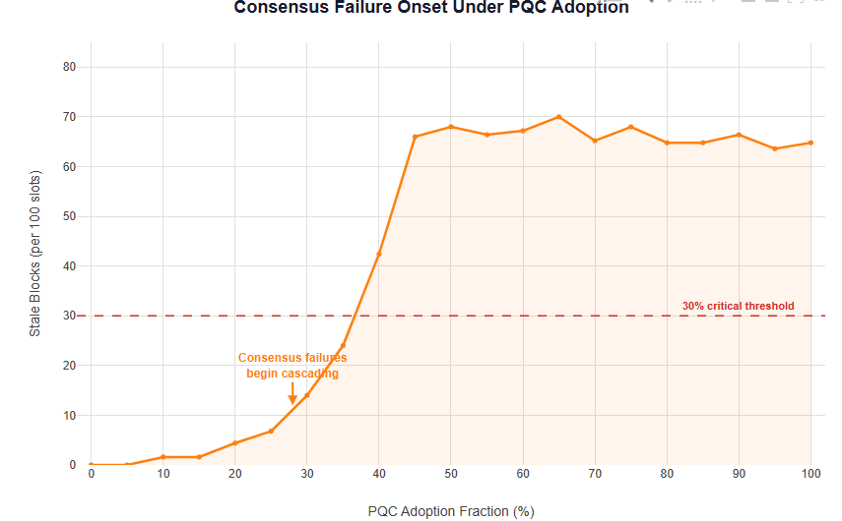
Figure 3: Stale block rate escalation. The 30% critical threshold is marked.
Effective throughput degrades in parallel with stale-rate escalation. Below ~45% PQC, all transactions fit within the 6 MB block. Above this threshold, block truncation forces transaction eviction: effective TPS drops from 4,164 at 0% PQC to 2,695 at 100% PQC - a 35% throughput loss (Figure 4).
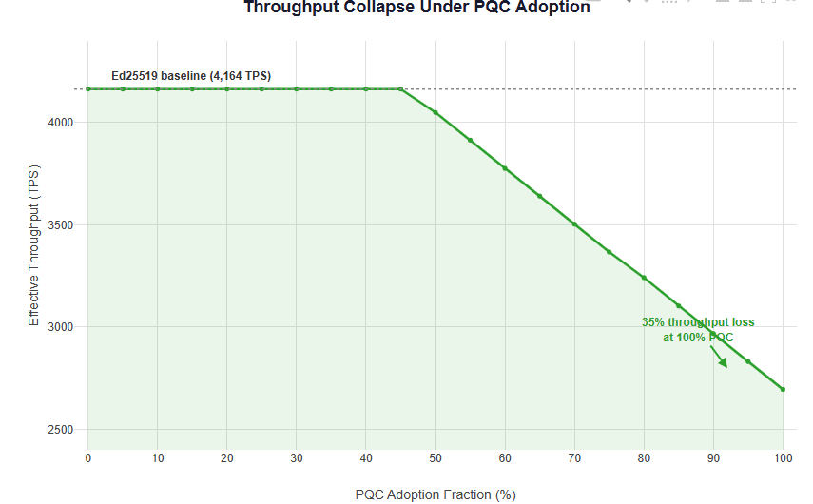
Figure 4: Effective throughput (TPS) collapse as PQC adoption increases.

4.4 The Critical Threshold
Interpolating between the 35% PQC level (24.0% stale rate) and the 40% PQC level (42.4% stale rate), the 30% stale-rate crossing occurs at approximately 37% PQC adoption (±5 percentage points, reflecting the 5 pp granularity of the sweep and the high inter-seed variance at this boundary). This represents a qualitative shift in network behaviour. Below approximately 35%, the network operates in a regime of graceful degradation: block sizes grow, propagation slows, and some blocks are lost, but the system remains fundamentally viable. Above ~37%, cascading consensus failures emerge: the elevated stale rate renders marginal validator operations economically unviable (validators lose ~1 in 3 blocks), driving exit of marginal operators, which further concentrates the validator set and counterintuitively may reduce propagation delays for remaining validators - but at the cost of centralisation that undermines the network’s security model.
Important caveat. The ~37% threshold is identified under idealised routing assumptions without NIC contention: each gossip transmission receives the full sender bandwidth independently, and there is no queuing delay from concurrent transmissions. In a production network with NIC sharing, router congestion, and higher transaction volumes, the effective threshold would likely be significantly lower. The ~37% figure should therefore be interpreted as an optimistic upper bound on the onset of cascading failure, not as a precise prediction of where real-world networks would degrade.
Why 30% stale rate? The choice of 30% reflects economic viability: validators losing approximately 1 in 3 blocks face severe revenue destruction that renders marginal operations infeasible for those with narrow profit margins, driving validator exit and network centralisation - the decentralisation crisis analysed in Section 6. While the precise threshold varies by validator cost structure, geography, and token economics, 30% represents a conservative estimate of where marginal validator operations become economically unviable and mass exit would begin.
Statistical caveat. Each PQC adoption level was simulated with 10 independent seeds, each producing ~25 blocks (10 s at 400 ms slots). The per-level sample size is therefore approximately 250 blocks. For metrics at the extremes of the distribution (e.g. max stale rate, P90 propagation), the inter-seed variance is substantial - standard deviations at 40-100% PQC adoption are typically ±27-30 pp for stale rate. Reported means are stable across seeds, but individual-seed outliers (e.g. 96% max stale rate) reflect the stochastic tails of a small network simulation, not a point estimate of mainnet behaviour. A larger seed count or longer per-run duration would narrow these confidence bands.

4.5 Verification Time: The Non-Bottleneck
The surprising result is the negligible role of computational verification overhead. At 0% PQC, the average per-block verification time is approximately 10.9 ms - 2.7% of the 400 ms slot. At 100% PQC, despite the inclusion of SLH-DSA-128f signatures (which individually require ~5,940 µs), the average verification time grows to only 64.6 ms - still just 16.2% of the slot budget. Even accounting for the conservative margins built into the PQC verification model (Section 3.4), computation remains overwhelmingly within budget at all PQC adoption levels.
This finding challenges a common assumption in discussions of PQC-blockchain integration: that computational overhead, rather than bandwidth constraints, will be the primary bottleneck. The simulator demonstrates that bandwidth, not compute, is the binding constraint.

4.6 Root Cause Analysis: Bandwidth vs Compute
The root cause of network degradation can be decomposed into two orthogonal channels: (i) the bandwidth channel, driven by block size expansion affecting propagation delay; and (ii) the compute channel, driven by increased verification time per signature.
Block size grows 10.4× (563 KB → 5,858 KB). This drives propagation P90 from 186 ms to 381 ms (a 2.1× increase), consuming 95% of the slot. Verification time grows 5.9× (10.9 ms → 64.6 ms), but the absolute magnitude remains a modest fraction of the 400 ms slot. The asymmetry is stark: the bandwidth channel consumes 95% of the available time budget, while the compute channel consumes 16.2%. The ‘bloat matrix’ - PQC’s oversized signatures creating oversized blocks - is the dominant failure mode. Protocol mitigations must therefore prioritise bandwidth reduction (signature aggregation, proof compression, adaptive block sizing) over computational optimisation (hardware acceleration, parallelised verification).
Table 3: Bandwidth vs compute decomposition at 0% and 100% PQC adoption.
Metric | 0% PQC | 100% PQC | Growth | % of 400 ms Slot
Block Size | 563 KB | 5,858 KB | 10.4× | —
P90 Propagation | 186 ms | 381 ms | 2.1× | 95.3%
Verification Time | 10.9 ms | 64.6 ms | 5.9× | 16.2%
Stale Rate | 0.0% | 64.8% | — | —
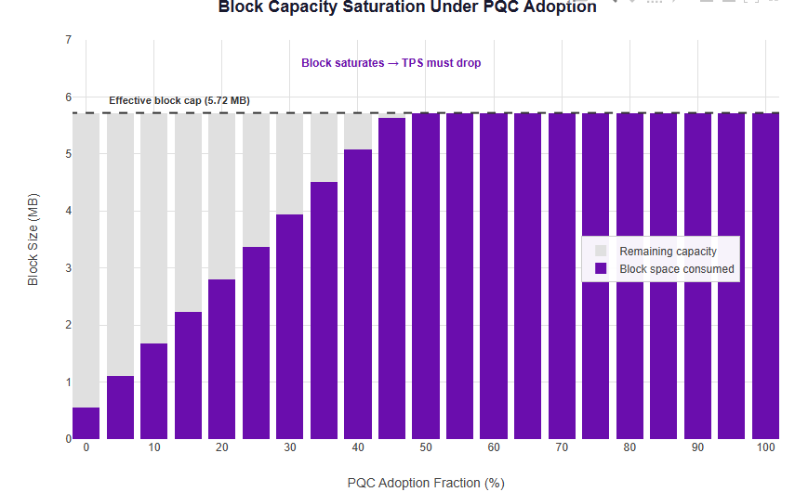
Figure 5: Block capacity saturation - bandwidth breakdown (stacked bar).

4.7 Baseline Calibration
At 0% PQC adoption, the simulator produces a mean stale rate of 0.0% across all 10 seeds, with a P90 propagation delay of 186 ms (46.4% of the 400 ms slot) and mean block size of 563 KB. By comparison, Solana mainnet’s observed slot skip rate during 2024-2025 is approximately 5%. The simulator’s lower baseline is expected: the skip rate on mainnet reflects multiple real-world factors absent from the model - validator software bugs, consensus voting overhead, leader rotation latency, clock drift, and transient network partitions - none of which relate to signature size or verification time. The simulator intentionally isolates the PQC signature-size channel by holding all other factors constant. The 186 ms P90 baseline is consistent with the order-of-magnitude scaling implied by Deck and Wattenhofer’s [22] empirical propagation model (~80 ms per KB for blocks exceeding 20 KB on the Bitcoin network). It should be noted that their study covered a larger network (~4,000 nodes) and absolute values are not directly compatible.

4.8 Sensitivity Analysis: Algorithm Mix
The default sweep uses the PQC mix defined in Section 3.3. Since SLH-DSA-128f produces 17,088-byte signatures - 5-7× larger than ML-DSA and 26× larger than Falcon-512 - the results are potentially sensitive to its 20% allocation. To quantify this sensitivity, two additional 210-run Monte Carlo sweeps were executed with alternative mixes:
Mix A - Falcon-dominant: Falcon-512 (70%), ML-DSA-65 (20%), SLH-DSA-128f (10%).
Mix B - ML-DSA-only: ML-DSA-44 (60%), ML-DSA-65 (40%), SLH-DSA-128f (0%).
Table 4: Block size (KB) under three algorithm mixes across PQC adoption levels.
PQC % | Default (KB) | Falcon-dom (KB) | ML-DSA-only (KB)
0% | 563 | 563 | 563
25% | 3,448 | 2,093 | 2,291
50% | 5,859 | 3,643 | 4,030
75% | 5,859 | 5,168 | 5,754
100% | 5,858 | 5,858 | 5,858

Table 5: Mean stale rate (%) under three algorithm mixes.
PQC % | Default | Falcon-dom | ML-DSA-only
0% | 0.0% | 0.0% | 0.0%
25% | 6.8% | 1.6% | 2.8%
50% | 68.0% | 8.8% | 12.0%
75% | 68.0% | 44.0% | 62.0%
90% | 66.4% | 68.8% | 61.2%
100% | 64.8% | 68.0% | 67.2%
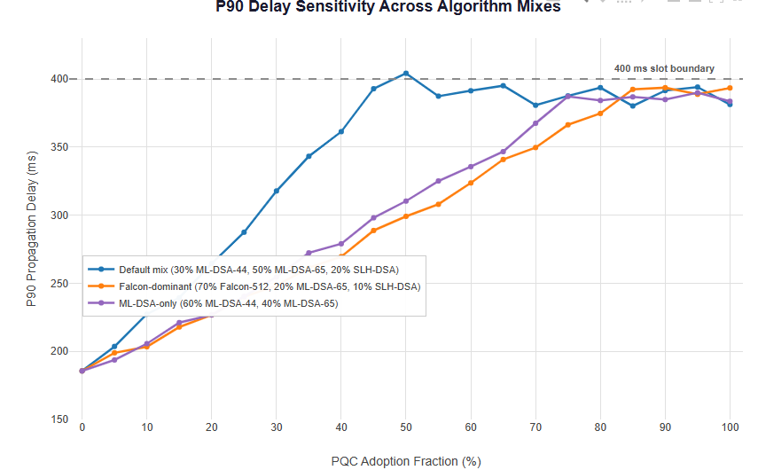
Figure 6: P90 propagation delay sensitivity across three algorithm mixes.
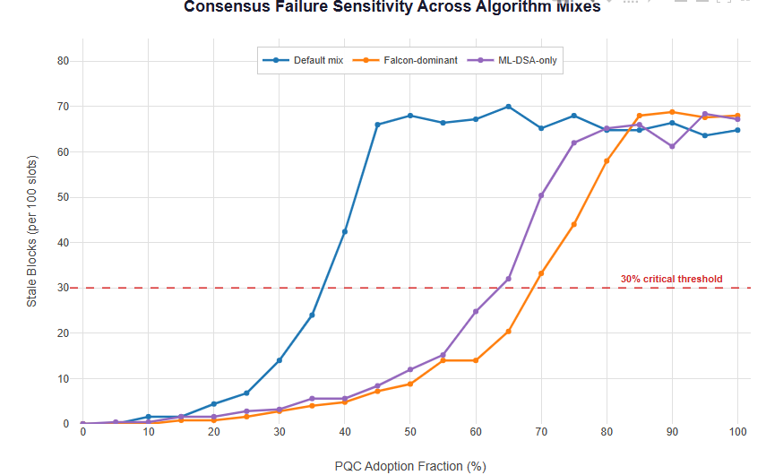
Figure 7: Stale block rate sensitivity across three algorithm mixes.
The results reveal that the algorithm mix is the single most consequential design variable in PQC migration - but at λ = 4,000 TPS, no algorithm mix avoids catastrophic failure at full adoption. At 50% PQC adoption, the default mix (with 20% SLH-DSA-128f) produces a 68.0% stale rate and ~5,859 KB mean block size, already at the cap. The Falcon-dominant mix delays the onset of severe degradation: at 50% PQC, Falcon produces only 8.8% stale rate with 3,643 KB blocks - still well below the cap. The ML-DSA-only mix achieves 12.0% stale rate at 4,030 KB. However, all three mixes eventually hit the 6 MB cap and converge to similar stale rates at 100% PQC: 64.8% (default), 68.0% (Falcon), and 67.2% (ML-DSA-only).
The critical threshold shifts substantially with algorithm choice. The default mix crosses 30% stale rate at ~37% PQC adoption. The Falcon-dominant mix delays this threshold to ~69% PQC, and the ML-DSA-only mix to ~64% PQC. These gains are driven by smaller per-transaction signature sizes keeping blocks below the 6 MB cap at higher PQC fractions. However, the convergence at 100% PQC demonstrates that at production-level transaction rates, the 6 MB block size limit is the ultimate binding constraint: once all mixes fill blocks to the cap, propagation times and stale rates converge regardless of algorithm choice.
The policy implication is clear: protocol designers can substantially delay PQC’s impact by steering adoption towards smaller-signature algorithms (Falcon-512 at 666 bytes, or ML-DSA-44 at 2,420 bytes) and discouraging SLH-DSA for high-throughput chains. However, SLH-DSA’s conservative hash-based security model - relying only on hash-function collision resistance rather than lattice assumptions - makes it a valuable defence-in-depth option. The trade-off between signature size and cryptographic diversity is a first-order protocol design decision.

5. Discussion

5.1 Vote Transaction Implications
On Solana mainnet, approximately 70-80% of block space is consumed by validator vote transactions, each requiring a signature. The simulator does not model vote transactions separately; all transactions are treated as user transactions. This simplification creates a dichotomy that warrants explicit analysis.
If vote signatures migrate to PQC alongside user transactions, the bandwidth crisis arrives far earlier and more severely than the model shows. At 70% vote overhead, effective user block space shrinks from 6 MB to 1.8 MB. Under the default PQC mix, an Ed25519 user transaction occupies 346 bytes (250 + 64 + 32), fitting approximately 5,202 user transactions in 1.8 MB. A weighted-average PQC transaction under the default mix occupies approximately 7,424 bytes, fitting only 242 user transactions in the same 1.8 MB - a 21.5× reduction in user throughput. The 6 MB cap would become binding at near-zero PQC user adoption because vote transactions alone would consume most of the block budget.
If votes remain on Ed25519 during a transition period, the bandwidth pressure is deferred, but the consensus critical signature layer - the mechanism that finalises the chain - stays quantum-vulnerable. This partially defeats the purpose of migrating user transactions to PQC. Either fork of this analysis strengthens the overall thesis: PQC migration is harder than naïve substitution suggests, and the order in which different transaction types migrate is itself a first-order protocol design decision.

5.2 Fee Market Dynamics and Dual Failure Modes
The simulator uses a fixed transaction arrival rate (λ = 4,000 TPS) with no dynamic fee market. In a production network, fee markets would act as a pressure valve: as blocks approach capacity, fees rise, marginal transactions are priced out, effective TPS drops, and block utilisation stabilises below the cap. This feedback loop means the stale-rate numbers at high PQC fractions likely overstate the consensus failure mode (blocks too large to propagate) while understating the economic failure mode (transactions too expensive to submit).
However, fee-market throttling does not solve the problem - it transforms it. A network where PQC signature bloat has consumed so much block space that fees must spike to clear the market is a network that has lost most of its throughput and priced out most of its users. The simulator captures the consensus failure mode (stale blocks); production networks would likely experience the economic failure mode (fee explosion and throughput collapse) first, with consensus failure as the backstop. Either way, naïve PQC substitution without protocol-level mitigation renders high-throughput chains non-viable.

5.3 Algorithm Mix as Policy Variable
The sensitivity analysis (Section 4.8) demonstrates that the algorithm mix is the single most consequential variable in determining when the critical threshold is reached: ~37% PQC adoption under the default mix (Section 3.3), ~64% under ML-DSA-only, and ~69% under Falcon-dominant. The default mix includes 20% SLH-DSA-128f, whose 17,088-byte signatures are 5-7× larger than ML-DSA and 26× larger than Falcon-512. In a functioning fee market, SLH-DSA transactions would cost roughly 50× more than legacy Ed25519 transactions, making 20% adoption economically implausible without explicit subsidy or regulatory mandate.
The inclusion of SLH-DSA in the default mix is nonetheless defensible as a conservative modelling choice: SLH-DSA is the only NIST-standardised signature relying purely on hash-function security rather than lattice assumptions, making it a valuable hedge against future lattice cryptanalysis. Institutional or regulatory mandates could plausibly require hash-based diversity regardless of cost. The default mix should therefore be understood as a conservative (worst-plausible-case) scenario rather than a market prediction, while the Falcon-dominant and ML-DSA-only mixes represent more market-realistic outcomes. The choice of algorithm mix is itself a first-order protocol policy decision.

6. The Decentralisation Crisis

6.1 Validator Economics Under PQC Stress
The simulator’s findings must be interpreted against the backdrop of existing validator economics. Solana’s validator set has contracted from ~2,560 in early 2023 to approximately 795 by January 2026 [27] - a 68.9% decline - with annual voting costs alone reaching ~$49,000 per validator. The Nakamoto Coefficient fell from 34 to 20 over the same period.
PQC-induced data bloat would compound these existing pressures. The Journal of the British Blockchain Association [24] estimates that 50-80% of current Ethereum nodes would be priced out of operation under full PQC migration without state compression. For Solana, where validator hardware already costs $20,000-$50,000, PQC storage growth towards 35-160 TB would be most severely felt by mid-tier operators who cannot absorb hardware refresh costs.

6.2 The Stale Block Tax
At a 30% stale rate - the threshold identified at ~37% PQC adoption (see Section 4.4 for caveats) - validators lose approximately 1 in 3 blocks they produce. For Bitcoin, where a single block reward at $70,000 per BTC exceeds $200,000, this represents severe revenue destruction for all but the most well-connected operators. The foundational work of Decker and Wattenhofer [22] established that propagation delay scales linearly with block size and that a well-connected hub node could unilaterally reduce the fork rate by 53% - demonstrating that topology and connectivity are already centralisation vectors.
The SOK analysis by Mallick et al. [25] quantifies this directly: a 10× block size increase raises Bitcoin’s fork probability from 1.69% to approximately 17.6% - a tenfold multiplication of the stale rate. The simulator’s Solana-parameterised results are consistent with this scaling: at 10.4× block expansion (corresponding to 50% PQC and above, where blocks hit the cap), the mean stale rate reaches 68.0%, driven by P90 propagation delays that exceed the slot boundary.

6.3 Geographic Inequality
The International Telecommunication Union (ITU) [26] reports that high-income countries have 8× the bandwidth per capita of low-income countries, and that fixed broadband costs approximately 30% of monthly income in low-income nations. The 1 Gbps symmetric connection required for Solana validation is simply not commercially available at any price in many Global South jurisdictions.
As of January 2026, 61% of Solana’s validator stake was concentrated in the European Union. PQC bloat disproportionately affects validators in bandwidth-constrained regions: applying Decker and Wattenhofer’s [22] 80 ms/KB delay scaling, an uncapped PQC-expanded block would arrive at a bandwidth-constrained validator over a second later than at the originating node - enough to guarantee that any block produced during that window becomes stale.

6.4 The Centralisation Feedback Loop
The dynamics identified above form a self-reinforcing positive feedback loop. Larger blocks extend propagation delays, elevating stale rates. Elevated stale rates render the economics of small and geographically disadvantaged validators unviable, forcing their exit. The remaining validators - predominantly data-centre operators in low-latency network corridors - enjoy improved propagation advantage precisely because there are fewer competitors with inferior connectivity. This further concentrates the validator set, widening the advantage gap in subsequent rounds.
This dynamic closely resembles the Bitcoin Block Size Wars (2015–2017), where the central argument was identical: increasing block capacity raises node hardware requirements, causing individual operators to exit and leaving validation concentrated among data-centre operators severely degrading censorship resistance. PQC migration imposes qualitatively the same trade-off, with the added complication that the protocol change provides no throughput benefit - it is as characterised by the JBBA paper [24], ‘a purely defensive measure imposing only costs.’

6.5 Cloud Provider Concentration Risk
PQC-driven hardware requirements exceeding residential infrastructure would migrate validator operation towards cloud providers (AWS, GCP, Hetzner, OVH), creating a qualitatively different concentration risk. The Brookings Institution’s 2025 analysis [28] identifies cloud dependency as a systemic risk: ‘a single compromised entity - such as a cloud provider or a financial institution - can expose millions of users to security risks.’

7. Mitigations & Future Work

7.1 Hybrid Signatures
NIST SP 800-227 [29] and the IETF composite ML-DSA Internet-Draft [30] formally specify how classical and PQC algorithms can be combined in a single signature object. An Ed25519 + ML-DSA-65 composite signature totals approximately 3,373 bytes - providing defence-in-depth during the transition period, since the combined signature remains secure as long as either component is unbroken. The most visible deployment of hybrid PQC is in TLS key exchange. Beginning with Chrome 116 in August 2023, Google deployed X25519Kyber768, with Cloudflare reporting that over one-third of human HTTPS traffic used hybrid post-quantum handshakes by March 2025 [31]. The limitation for blockchain is that hybrid signatures incur strictly additive size overhead [32] - the combined signature is always larger than either component alone.

7.2 Falcon as a Middle Ground
Falcon-512 (FN-DSA) produces 666-byte signatures - approximately 5× smaller than ML-DSA-65 and only ~10× larger than Ed25519. For blockchain applications where per-transaction bandwidth is the binding constraint, Falcon represents the most favourable size profile among NIST-approved algorithms. However, Falcon’s implementation involves discrete Gaussian sampling over NTRU lattices using FFT-based trapdoor sampling, described by its principal author Thomas Pornin as ‘by far the most complicated cryptographic algorithm I have ever implemented.’ Multiple academic demonstrations of successful timing and electromagnetic side-channel attacks against insufficiently hardened Falcon implementations underscore the engineering challenge. FIPS 206 remains pending as of February 2026.

7.3 Signature Aggregation
The LaBRADOR lattice-based proof system [33] demonstrates that 10,000 Falcon-512 signatures can be aggregated into a 74 KB proof - approximately 90× compression. However, verification of the aggregated proof requires 2.65 seconds, which is too slow for Ethereum’s 12-second slot (shared with many other consensus tasks) and prohibitive for Solana’s 400 ms slot. Sequential Dilithium (ML-DSA) aggregation has been explored by Boudgoust et al. [34], but compression only begins to exceed trivial concatenation beyond N > 69 signatures, with an asymptotic compression ratio of only ~0.99.

7.4 Zero-Knowledge Proof Compression
ZK-STARKs are inherently post-quantum secure because their security rests solely on hash-function collision resistance, unlike pairing-based SNARKs which rely on elliptic-curve hardness. A Delving Bitcoin proposal [35] argues for using recursive STARKs to aggregate all PQC signatures in a block into a single proof. The PQCee proposal by Tan et al. [36] evaluates this architecture concretely: users augment legacy transactions with a zkSTARK proof of secret-key knowledge, and a Layer-2 rollup node recursively aggregates these proofs, submitting a single final proof via EIP-4844 blob transaction. This could enable near-zero marginal cost per PQC signature in a batch. The constraint is prover hardware: current benchmarks require 256 GB memory for recursive aggregation of 10 proofs.

7.5 Protocol-Level Mitigations
Ethereum’s gas limit has doubled in a single year [37] (30M → 60M by November 2025), with a medium-term target of ~300 million gas, substantially increasing headroom for PQC transactions. EIP-4844 [38] (proto-danksharding, March 2024) introduced blob transactions storing up to 128 KB of ephemeral data per blob - ideal for posting aggregated PQC proofs without incurring permanent calldata costs. Full Danksharding [39] will increase effective block data to approximately 32 MB via data availability sampling (DAS), where validators store only 2D fragments of each blob and light clients probabilistically confirm availability. FRIDA [40] has been proposed as a post-quantum alternative to the KZG commitment scheme used in Danksharding, since KZG relies on pairing-based cryptography vulnerable to Shor’s algorithm.

7.6 Open Questions for Future Work
Several critical questions remain open. Can adaptive block sizes respond dynamically to PQC load - for example, by expanding the slot interval when PQC transaction density exceeds a threshold? What is the optimal PQC signature mix for each chain, balancing implementation complexity against bandwidth savings? How do Layer 2 rollups change the migration calculus, given that ZK-rollups already achieve significant signature compression? What is the realistic hardware acceleration timeline for PQC verification, and does it align with Q-Day? Beyond these immediate questions, the centralisation feedback loop (Section 6.4) implies that as validators exit under stale-rate pressure, propagation improves and economics stabilise at a new equilibrium - but the cost in decentralisation is unknown. Future work should model validator-set contraction under PQC stress to determine whether stale rates return below 30%, and at what cost to the Nakamoto Coefficient. Finally, protocol-level circuit-breakers (stale-block slashing, geographic diversity incentives, tiered validator roles) could potentially interrupt the centralisation loop; modelling their effectiveness is a natural extension of this simulator.

8. Conclusion
Through 210 independent discrete-event simulations across a 75-node network, naïve substitution of NIST-standardised post-quantum signatures into a high-throughput blockchain triggers a sharp onset of cascading consensus failure driven overwhelmingly by bandwidth consumption rather than computational verification overhead. Mean block size grows 10.4× under the default PQC mix, P90 propagation delay consumes 95% of the 400 ms slot window, and the stale block rate first exceeds the 30% critical threshold at approximately 37% PQC adoption - an optimistic upper bound given the absence of NIC contention in the model. Sensitivity analysis reveals this threshold is strongly algorithm-dependent, shifting to ~64% under ML-DSA-only and ~69% under Falcon-dominant mixes, confirming that algorithm selection is a first-order protocol design decision.
The central implication is that PQC migration cannot be treated as a drop-in cryptographic upgrade. Without complementary protocol-level mitigations - signature aggregation, zero-knowledge proof compression, adaptive block sizing - the bandwidth inflation from PQC signatures would render high-throughput chains non-viable, severely degrading censorship resistance through validator centralisation long before full adoption is reached. With Q-Day approaching, at most a single decade remains for protocol-level preparation.

References
[1] Proos, J. and Zalka, C. "Shor's discrete logarithm quantum algorithm for elliptic curves." Quantum Information & Computation, 3(4), 2003.
[2] NIST, "Module-Lattice-Based Digital Signature Standard," FIPS 204, August 2024. https://nvlpubs.nist.gov/nistpubs/fips/nist.fips.204.pdf
[3] NIST, "Stateless Hash-Based Digital Signature Standard," FIPS 205, August 2024. https://csrc.nist.gov/pubs/fips/205/final
[4] Rötteler, M., Naehrig, M., Svore, K.M., Lauter, K. "Quantum Resource Estimates for Computing Elliptic Curve Discrete Logarithms," ASIACRYPT 2017.
[5] Litinski, D. "How to compute a 256-bit elliptic curve private key with only 50 million Toffoli gates," 2023.
[6] Babbush, R. et al. "Computing 256-bit Elliptic Curve Logarithm in 9 Hours with 126,133 Cat Qubits," 2023.
[7] Dallaire-Demers, P. et al. "Brace for Impact: ECDLP challenges for quantum cryptanalysis," 2025. https://postquantum.com/quantum-research/ecdlp-challenge-ladder/

[8] https://www.ibm.com/quantum/roadmap

[9] Google Quantum AI, "Meet Willow, our state-of-the-art quantum chip," Google Blog, Dec. 2024. https://blog.google/technology/research/google-willow-quantum-chip/
[10] PostQuantum, "IonQ's 2025 Roadmap: Toward a CRQC," 2025. https://postquantum.com/industry-news/ionqroadmap-crqc/
[11] Global Risk Institute, "Quantum Threat Timeline Report," 2024. https://globalriskinstitute.org/publication/2024-quantum-threat-timeline-report/
[12] Chaincode Labs, "Bitcoin and Quantum Computing," 2025. https://chaincode.com/bitcoin-post-quantum.pdf
[13] NIST, "NIST IR 8547: Transition to Post-Quantum Cryptography Standards," Nov. 2024. https://csrc.nist.gov/pubs/ir/8547/ipd
[14] NSA, "CNSA 2.0 FAQ," Version 2.1, December 2024. https://media.defense.gov
[15] Mascelli, J. and Rodden, M. "Harvest Now Decrypt Later," Federal Reserve FEDS Working Paper 2025-093, Sep. 2025. https://www.federalreserve.gov/econres/feds/harvest-now-decrypt-later
[16] Federal Register, "Announcing Issuance of FIPS 203, 204, and 205," 14 August 2024. https://www.federalregister.gov/documents/2024/08/14/
[17] PostQuantum.com, "PQC Standardisation -- 2025 Update." https://postquantum.com/post-quantum/cryptography-pqc-nist/
[18] The Quantum Insider, "Ethereum Foundation Elevates Post-Quantum Security to Top Strategic Priority," Jan. 2026. https://thequantuminsider.com/2026/01/26/ethereum-foundation-elevates
[19] BeInCrypto, "Vitalik Buterin Says Ethereum Will Soon Achieve Quantum Resistance," Feb. 2026. https://beincrypto.com/vitalik-buterin-ethereum-quantum-resistance/
[20] Forbes, "Bitcoin Took Its First Step Against Quantum Computers," Feb. 2026. https://www.forbes.com
[21] PR Newswire, "Project Eleven to Advance Post-Quantum Security for Solana," Dec. 2025. https://www.prnewswire.com
[22] Decker, C. and Wattenhofer, R. "Information Propagation in the Bitcoin Network," IEEE P2P 2013. https://tik-db.ee.ethz.ch
[23] wolfSSL, "wolfCrypt Benchmarks," 2025. https://www.wolfssl.com/documentation/manuals/wolfssl/appendix07.html
[24] Campbell, R. "Hybrid Post-Quantum Signatures for Bitcoin and Ethereum," JBBA, 2025. https://jbba.scholasticahq.com/article/154321
[25] Mallick, T. et al. "An SOK of How Post-Quantum Attackers Reshape Blockchain Security," arXiv:2512.13333, Dec. 2025. https://arxiv.org/html/2512.13333v1
[26] ITU, "Measuring Digital Development: Facts and Figures 2025." https://giga.global

[27] https://finance.yahoo.com/news/solana-loses-two-thirds-validators-125255131.html?guccounter=1&guce_referrer=aHR0cHM6Ly93d3cuZ29vZ2xlLmNvbS8&guce_referrer_sig=AQAAALs6RzLpjpyfGRDBhTC4W1UqxifOflqE7yhMcQtpGQSdGjOvhsqEFm6Xzze28zGHG0HmoaKDdKja-h7pRatcWXlVQc6wFv31UIwuijxgQ8lU3_xdF6EGMaVauHMNJtYeExvEzAA2rj9Mq3-HF3rl-QmOZq6z3uLqUaSuPCwoP2iz

[28] Brookings Institution, "The Hidden Danger of Re-centralization in Blockchain Platforms," Apr. 2025. https://www.brookings.edu
[29] NIST, "Recommendations for Key-Encapsulation Mechanisms," SP 800-227, Sep. 2025. https://nvlpubs.nist.gov
[30] Ounsworth, M. et al. "Composite ML-DSA for X.509," IETF Internet-Draft, Oct. 2025. https://datatracker.ietf.org
[31] Cloudflare Blog, "Another look at PQ signatures," 2024. https://blog.cloudflare.com

[32] A16Z Crypto, "Quantum computing and blockchains," Dec. 2025. https://a16zcrypto.com

[33] Nevado, D., Kim, D., Stopar, M. "Lattice-based signature aggregation," Ethereum Research, May 2025. https://ethresear.ch
[34] Boudgoust, K. "Aggregating Lattice-Based Signatures," NTPQC Oxford, Jun. 2024. https://katinkabou.github.io

[35] Delving Bitcoin, "Post Quantum Signatures and Scaling Bitcoin with STARKs," Apr. 2025. https://delvingbitcoin.org

[36] Tan, X. et al. "Enabling a Smooth Migration towards Post-Quantum Security for Ethereum," PQCee, 2024. https://pqcee.github.io
[37] AMBCrypto, "Vitalik Buterin's 2026 Roadmap: Gas Limit Increase," Nov. 2025. https://ambcrypto.com
[38] EIP-4844.com, "Proto-Danksharding." https://www.eip4844.com
[39] A16Z Crypto, "Danksharding Overview and DAS Proposal," 2023. https://a16zcrypto.com
[40] ZK/SEC Quarterly, "FRIDA: Data-Availability Sampling from FRI," Jun. 2024. https://blog.zksecurity.xyz

